Access Cards----Extended Corporate Applications

Can access cards be applied to corporations for purposes other than employee identification, door control and attendance management? Can a card be used diversely and realize a model of multiple intelligence management applications? We provide a comprehensive corporate application system applicable to, for example, dormitory power-saving and door control applications, mess hall payment applications, meal order systems, parking lot control systems, multi-function printer controls, employee benefits allocations, concessional commodity payment applications, visitor systems, and guard patrol sign-on systems. It provides all the required software and hardware to provide a total solution for enterprises.

- Value storage systems integrated with allocations of employee benefits
Employees may consume in the company, such as utilization of electricity in the dormitory, dining in the mess hall of the company, and purchase of concessional commodities. Like EasyCard, employees may store money in the card to eliminate the shortcomings in use of the cash. We provide unattended automatic and manual note acceptor value loaders. You can select the product flexibly depending on your actual needs. In combination with the software, employee benefits or meal allowance can be stored in the automatic value loader monthly, and employees only need to access their individual benefits or meal allowance s from the automatic value loader.
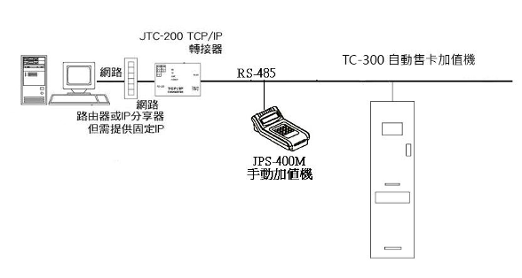

Adaptor
Network

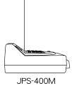
Network
Router or IP Share; Dedicated IP is needed

TUB-200 Currency Note Acceptor Value Loader

- Dormitory power-saving and door control application
Power consumption control of electric lights, air conditioners and other electric appliances is ensured by setting up consumption control equipment in the dormitory to avoid excessive consumption of electricity. A hi-tech sensor is used to control the power switch and proximity power-saving card readers are installed in conjunction with electronic watthour meters. User pays and reasonable power consumptions are ensured based on the “charge by consumption “principle according to the readings on the meter.

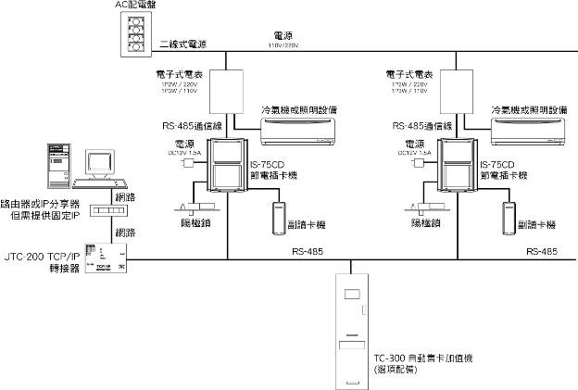
AC distributor
Two-wire power source
Power source
Electronic watthour meter
Electronic watthour meter
Air conditioner or lighting equipment
Air conditioner or lighting equipment
RS-485 cable
Power source
RS-485 cable
Power source
Network
Power-saving card machine
Power-saving card machine
Router or IP Share; Dedicated IP is needed
Network
Secondary card reader
Electric bolt
Secondary card reader
Electric bolt

Adaptor

TC-300 Note Acceptor with Card Dispenser (optional)

- Mess hall payment application
There is no need to split the proceeds in the catering system or sum up the meal payments any more. Employee benefits are stored in the employee identity card and the deduction is made directly from the card for either fixed or non-fixed payment. The product can be connected to a display or printer to explicitly show the amount of the payment and balance to the employee. The system is capable of generating different meal payment reports for the employee and summarized operation reports for the vendor as a reference for splitting the proceeds.
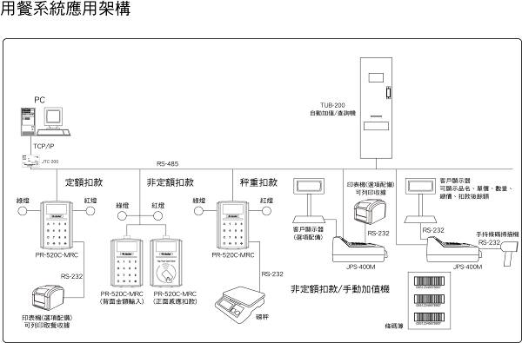
Mess hall system and application structure

Auto value loader/inquiry machine

Fixed payment
Non-fixed payment
Payment by weight
Printer (optional)
to print receipt
Customer display
to show item name, unit price, quantity, total price, balance
Green light
Red light
Red light
Red light
Green light
Green light
Customer display
(optional)
Portable barcode scanner

(Front: Deduction and payment)
Non-fixed payment / manual value loader
Printer (optional)
to print receipt
(Back: Enter the amount)
Scale
Barcode

- Meal ordering/taking management system
Do you still sum up meal orders using pens and paper? The meal ordering management system provides a faster and simpler tool to help you sum up the dishes you have ordered more quickly and free yourself from the troublesome meal ordering matters. The smart meal ordering system enables you to order specific meat and vegetable dishes or set a time frame for placing orders. You can use the system with applications to order a meal of different dishes or use it in combination with a card reader to take your meal. It can save you time to charge at the cashier’s desk and help you prepare and take the food according to the order quantity without wasting any ingredients.
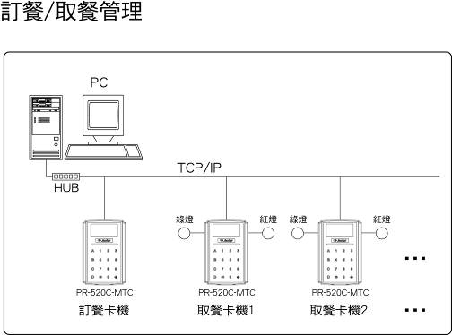
Meal ordering/taking management application

Red light
Red light
Green light
Green light

Meal ordering card reader
Meal taking card reader 1
Meal taking card reader 2

- Concessional commodity payment application
The company that provides concessional commodities for employees may edit different barcodes beforehand and use them in the barcode scanner and payment system. The system can be used in combination with applications to provide item names and accelerate the payment and charging process.
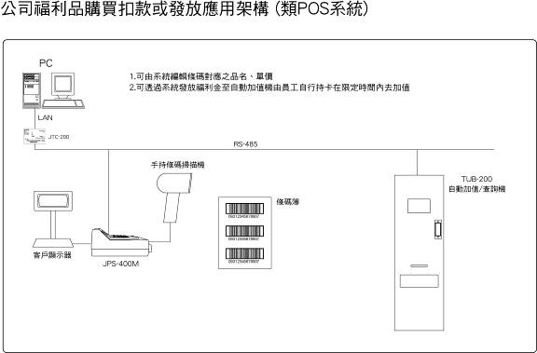
Purchase, payment or allocation structure of company’s concessional commodities (POS-like system)

- The system can be used to edit corresponding item names and unit prices for the barcode.
- Employee benefits can be allocated to the auto value loader via the system so that employees can add the value to their cards within the specified time frame.

Portable barcode scanner
Barcode
Auto value loader/inquiry machine

Customer display

- Lift control system
The lift control system provides an extended access control to prevent unauthorized access to the building and ensure the security of on each floor.
The system provides 4 control modes:
- Lift control: This is the access control of the lowest level. The employee can take the lift to every floor using a card.
- Floor control: Access to the floors is pre-set in the card and the employee can only press the buttons to the floors within the permit. When the employee presses the button to the floor beyond his/her the permit, the button does not respond.
- Lift hall control: Card sensors are set up at each floor and the employee cannot call the lift without holding a legal card. This is effective to prevent unauthorized employee from calling the lift and can save energy by minimizing the operations of the lift.
- The system can be used in combination with the user-pay principle and the value storage and payment functions to ensure that the more the lift is taken or the higher the floor is, the more the payment will be. It can improve the advantages and expand the application scope of the lift control system to the buildings with, for example, cram schools, beauty salons, gyms and so on.
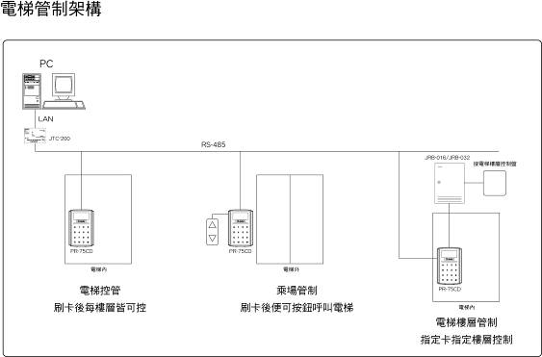
Lift control structure

Lift control panel

Inside the lift
Outside the lift
Lift control
Scanning and floor control
Lift hall control
Scanning and press button to call lift
Inside the lift
Floor control
Controlled card and floor

- Parking lot management
We use FECT e-Tag remote sensing technology to develop the parking lot management system for the community. Our system is one of the most advanced auto parking lot management solutions. It represents the trend in parking lot management and ensures the safety, stability and automation that manual management or close-range identification system cannot provide. The unforgettable feature and quick-identification capability will surely provide a brand-new total solution for parking lot management applications of all kinds. The system provides automatic identification, recording and release functions without the need to stop the vehicle. The management software at the backend is capable of checking the information of the vehicle, the entry/exit time, the report and payment record, the reminding message and performing other functions.
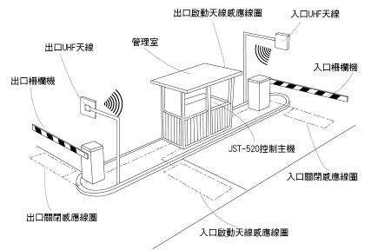
Activate aerial sending coil at exit
Entrance LHF aerial
Exit LHF aerial
Management office
Entrance fence
Exit fence

Control unit
Entrance close sensing coil
Exit close sensing coil
Activate aerial sending coil at entrance
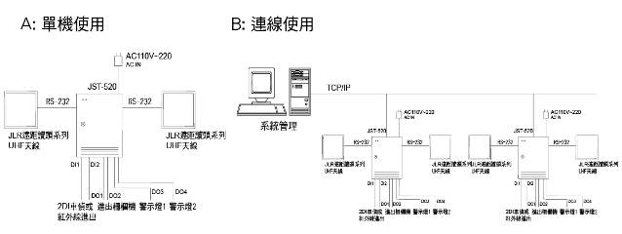
A: Standalone application
B: Networking application

System management
JLR Remote Head Series
UHF aerial
JLR Remote Head Series
UHF aerial
JLR Remote Head Series
UHF aerial
JLR Remote Head Series
UHF aerial
JLR Remote Head Series
UHF aerial
JLR Remote Head Series
UHF aerial
Warning light 1
Warning light 2
Warning light 1
Warning light 2
Warning light 1
Warning light 2
2DI vehicle detection/infrared sensing
2DI vehicle detection/infrared sensing
2DI vehicle detection/infrared sensing
Entrance/exit fence
Entrance/exit fence
Entrance/exit fence

- Visitor System
The visitors of the office building are traditionally managed by the safe guard or the administrator using written registration approaches. However, the truthfulness of the registered information cannot be recognized due to limited identification ability of the administrator. Meanwhile, there aren’t sufficient regulations for record management and the poor tracking ability cannot ensure comprehensive memorization and identification of the visitors. This may lead to a security vulnerability at the entrance and exit.
A comprehensive visitor management system is not simply an access control of the visitor area but is comprised of a visitor registration system, certification documents identification and filing function, photograph filing function, visitor form printing function as well as card issue and gate access management, card recycling management, access and lift control functions. The system can be extended to the area access control or the floor management and control, collection of employee’s access records when they are on and off their duty, collection of the visitor activity records, filing of documents, and printing of reports. An effective control and management of visitors can help identify the information precisely and save manpower and time needed for comparison and examination of a large amount of information.
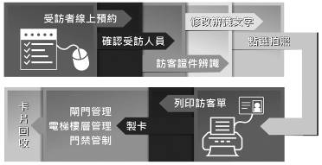
Interviewee makes appointment online
Modify the identified words
Click to take picture
Confirm the interviewee
Identify visitor’s certificate
Print out visitor form
Gate management
Lift and floor management
Access control
Retrieve the card
Make cards
- Electronic patrol sign-on system
Electronic patrol sign-on system replaces written patrol records in order to prevent shortcomings, such as allographs and sign-on after the patrol, and implement digitization, reduces carbon and saves energy.
There are two electronic patrol sign-on modes:
- Contactless patrol stick: This only requires a handheld induction stick. The patrol sign-on process can be completed in a second by aiming the stick at the sensor button. Electronic induction: The guard holds the proximity card stick near the electronic sensor to store the sign-on information instantly. The guard then uploads the patrol sign-on information to the server after returning to the guardroom and create records for checking purposes.
- Patrol with proximity card reader: The guard brings the proximity patrol card to the card readers along the patrol routes. The proximity patrol card will not open the door. The installation cost will be minimized by making use of the present card readers for planning of the patrol routes.
The patrol frequency will be increased because less sign-on time is needed thanks to the electronic patrol system. The system can ensure the security when used in combination with the management software as well as inquiry and audit functions.
Patrol system
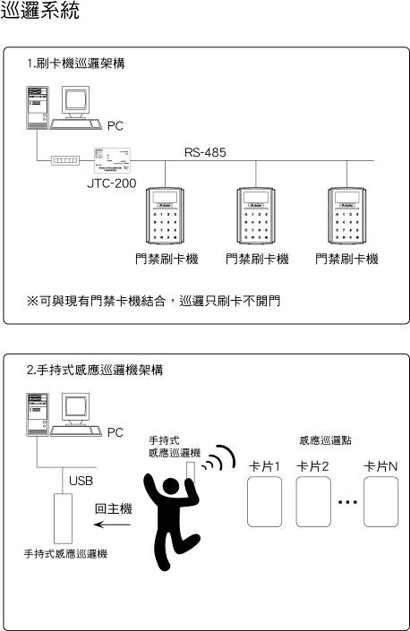
- Card reader patrol structure

Access control card reader
Access control card reader
Access control card reader
The system can work with existing access control cards. The door will not open when scanning the card.

- Portable proximity patrol reader structure

Portable
proximity patrol reader
Proximity control point
Card 1
Card 2
Card N
Back to the CPU

Portable proximity patrol reader

- Control of Multi-function Printers
Control becomes the most important management issue as the photocopying and printing requirements of the company grows continuously. The proximity card is the best choice to control the use of multi-function printers.
There are three photocopy control modes:
- Personal and departmental statistics: The user must scan the card before printing. Since every employee has a unique card, the scanning enables the user to accumulate his/her personal usage and, thus, the usage of the entire department. The system can be used in combination with applications to print out reports.
- Value storage and payment: The system can work with the value storage function and used for printing as long as there is a balance in the card. The value is deducted for every printing operation. When the balance is used up, printing is allowed only after more value is added to the card.
- Printer management software: The system works in combination with printer management software to control the printing. The user must scan the card to print out files.
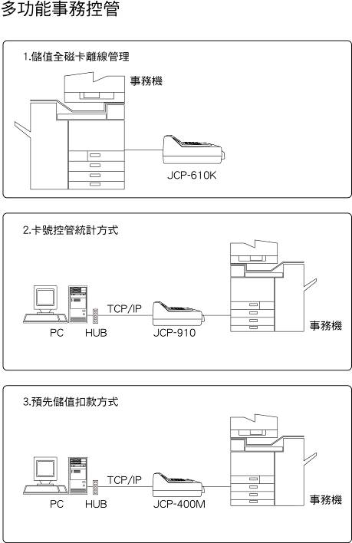
Printer
Printer
Printer
Off-line management of full magnetic card
Card number control and statistic approach
Payment approach pre-setting
Control of multi-function printers

